# Facebook Desktop App design patterns- Ex02 submitted by: Ido Barkan, Lee Khen

1. App description:   
   The app as a windows forms app designed to run on your desktop. The app connects to a user Facebook account, and after being granted the appropriate permissions supplies some basic Facebook features, plus two additional features.
2. Additional features:
   1. Find Facebook Check-ins within a specific area:   
      The app let the user define a circle shaped area and search from him all the check-ins that contains geographical information inside that area. The user can also define the oldest date from when he is interested of finding such check-ins. Following is an explanation of how this is done by the user:
      1. On the main screen the user clicks on 'Find Check-ins by near locations' button.
      2. The user is asked to input a search string describing the center of the area he is interested in. The app then suggests a few relevant specific places that match his search string. This is done behind the scene using Google Maps API. This specific place becomes the center point of the checking search area.
      3. After choosing the right specific place, the user should insert a date, a distance and a maximum results count.
         1. The date is the oldest check-in date the user is interested in.
         2. The distance (given in meters) is the radius of the search area.
         3. The maximum results count is the maximum number of relevant check-ins the user wants to get.
      4. After inputting the needed details the user click the GO button. The app the fetches all the user's friends' check-ins and searches those check-ins that are inside the search area. When the search is done, the relevant check-ins are shown to the user. Each check-in info can be clicked to show the check-in details (photos etc.). If no check-ins are found, the user get a popup message accordingly.
      5. Following is a sequence diagram of how this is done in the app:

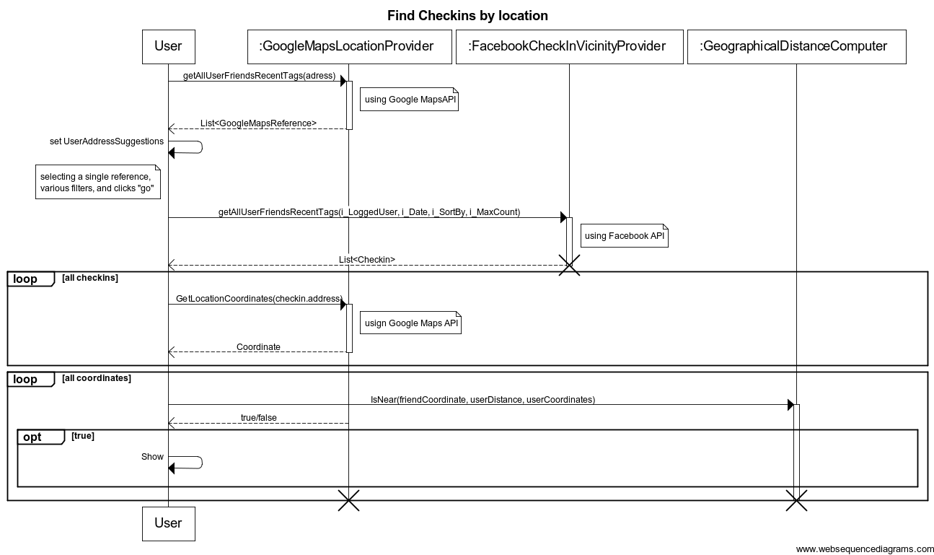

* 1. Suggesting friends by photos and events data.  
     Currently Facebook service can suggests new friends for the user by searching other Facebook users with common friends. The app suggests additional friends according to info found in photos and events of the user. Friend suggestions are created based on users that are tagged in the user's photos and on users that attended user's events. Following is an explanation of how this is done by the user:
     1. The user click on the 'Suggest friends by photos or events' button.
     2. The user is then presented with a new form allowing him to get friend suggestions by photo info and events info. The user can also input a max results number.
     3. When clicking on the photos button the app fetches all the user photos. It then sorts them and searches for users that are tagged in those photos that are not already friends with the user. The app takes the max number of users defined by the user and the matching users are then presented to the user. Following is a sequence diagram depicting how this is done by the app:

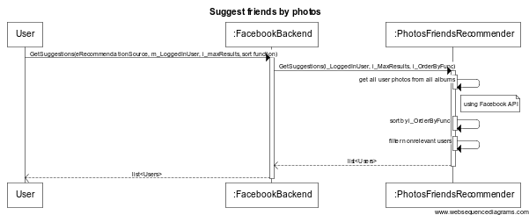

* + 1. When clicking on the Events button the app fetches all the user events. It then sorts them and searches for users that are tagged in those events that are not already friends with the user. The app takes the max number of users defined by the user and the matching users are then presented to the user. Following is a sequence diagram of how this is done by the app:

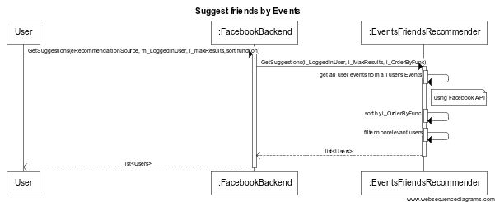

1. Use case diagram

